Group Gift Aid
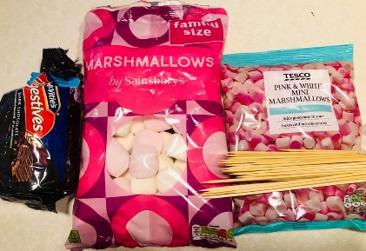
Gift Aid collection raises in excess of £800 each year providing vital funds to run Central Gosforth Group. We need to ensure that the data we hold for gift aid collection is correct which is easily done via our OSM platform, or by the Scouts HQ online forms (ask your Leaders)
Please could you check that your Gift Aid details are correct, and update OSM, even if you have provided the information before.

Ongoing Activities
All the groups have continued to meet on a regular basis online since the lockdown started in March. This has been extremely successful and enjoyable. Our amazing group of leaders and young leaders are being inventive with the challenges they set each week and activities that the children can take part in. They are using a mixture of full group and small group activities, some which require a little preparation between meetings. Scouts are successfully working towards skills and personal challenge badges. Leaders are trying to plan some face to face activities outside, and this will be done in line with current Covid-19 guidance.

Group Camps
It looks as though it will not be possible to plan a group camp in the near future.
In the meantime, a great number of Beavers, Cubs and Scouts took part in the world record Scout Association group camp during April – some camping for the whole month, and others having great fun setting up camp indoors.
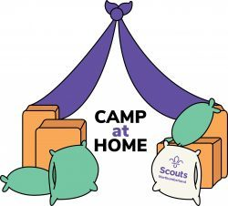
Well done to everyone who took part – and we hope you got your Scout Association certificate. Make sure you’ve let your leaders know how many nights you camped, as this can be added to your record for badges.
Scouts are having another camp at home this weekend, and making smores – marshmallows at the ready!
Oliver, our Beavers leader is organising camp out activities too. Our Cubs are hoping to go on a cycle ride, if government restrictions allow.

Community
Our Group loaned tents to Archbishop Runcie First School in the summer term. Seeing our community action, the Army then stepped in providing more tents. This enabled the whole of Year 4 to attend their last 3 weeks of first school.
Our camp food stock that would have gone to waste was donated to the foodbank collection point in Spar on Salters Road.
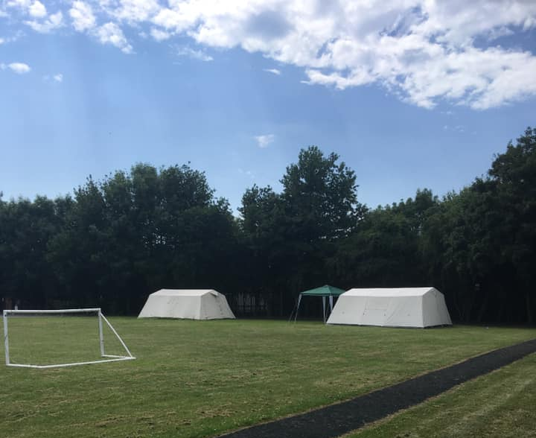

Group BBQ and AGM
Unfortunately our Annual Family Group BBQ was not held, and we cannot plan a similar group activity at the moment due to government restrictions on groups. However, our AGM will go ahead on Zoom – links and invitation to follow – on Friday 9th October at 7.30 – please attend if you can. As usual the AGM will include presentations from Beavers, Cubs and Scouts.

Scouts online
CLOSED Facebook groups (only visible by vetted members) have been set up to keep in touch and share information across the groups. If you have a Facebook account please request to join the “Central Gosforth Beaver Scouts“, “Central Gosforth Cubs” or “Central Gosforth Scouts” (for both All Saints & Montagu troops).
Using Zoom for online meetings has worked well. Leaders are following Scout Association guidance, and Scouts are reminded each session about proper and safe conduct. We do ask that parents/ carers are present nearby during meetings.
Across the groups we’ve had some really inventive online activities, including semaphore, knot tying, quizzes, treasure hunts, bingo and even a farm tour!!
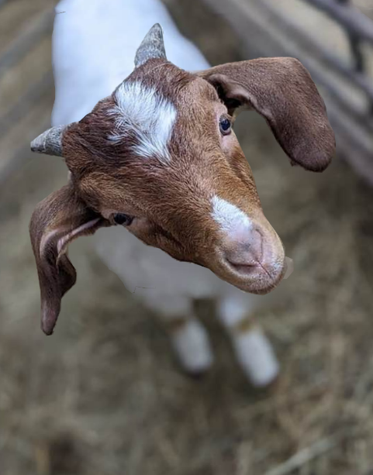

Volunteering and Training
We are always looking for people to help us run your Scout Group. You could help out in the sections or ‘behind the scenes’ as a member of the Executive Committee. The committee is voted in each year at the AGM and comprises of a chair, treasurer, secretary and executive members including section representatives. Please contact your section leader, any member of the executive committee, via website, or Caroline, your Group Scout Leader, by e-mail at ccampbellrose@aol.com
Many of our leaders and executive members have completed mandatory online GDPR, safety and safeguarding training over the summer break.
Check out our website at cgsg.scoutsites.org.uk
